# App Explanation: Excel format

## /Users/jsantillan/Desktop/Excel Maker/Screen Shot 2016-10-13 at 12.24.10 AM.png

Format:

A: Section; (What branch this is)

B: Name; Name/Commands go here

C: Line; Line/Command text goes here

D: Support; Where Convers Branches to from commands

Commands (Needs a * each time)

*Note

Makes the Line a note that doesn’t appear in game

*Menu

Makes a Menu where the player picks a dialog option

*Jump

Jumps to a specific dialog

*If (EventName)

*If_End

Makes a statement to say something if player did some event

Things between *if and *If_end will only be said if the Player did said event

You can put other commands in between *if commands, even other *if commands.

*Else

*Else_End

Works only if follows an *If_End, and if the Event was not activated.

Otherwise works the same as the *If command

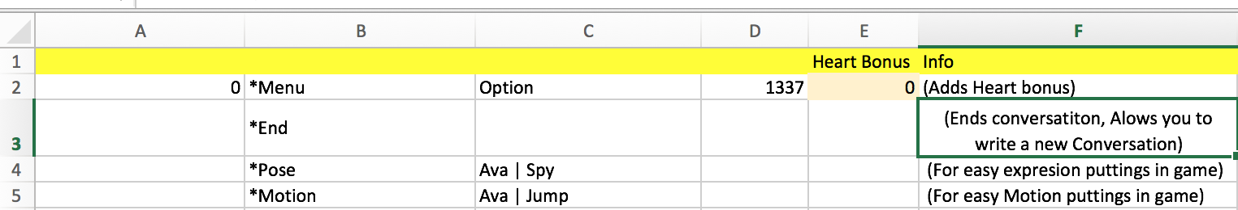

Commands in Development:

*Menu (with heart bonus)

Planning to add the component that determines the heart bonus/penalty per option

*End

Ends Conversation

*New

Ends conversation and allows the writer to start a new conversation

*Pose

-For Animator uses- Sets a pose for a girl

*Motion

-For Animator uses- Sets a Motion for a girl